LAB 9: OPTIONAL LAB
Constraints: Complex Design Considerations

OUTLINE
I. Clock Spec
II. Input Port Delays
III. Output Port Delays
IV. External Load, Inputs Ports

Design Schematic
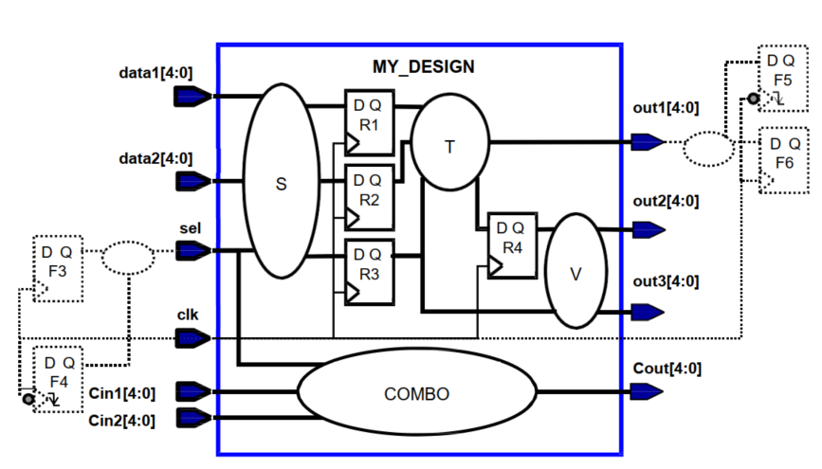

I. Clock Spec
DESIGN SPECIFICATION | COMMAND AND  COMMAND EXPLANATION
1. Rename the clock from “clk” to “my_clk”  2. Change the duty cycle to 40% active high, with zero offset. | Command:  create_clock -name my_clk -period 3.0 -waveform {0 1.2} [get_ports clk]  Explantion:  + create_clock defines a new clock named my_clk on the same input port.  + -period 3.0 assigns a 3 ns period (333.33 MHz) clock, consistent with the design frequency.  + -waveform {0 1.2} defines the clock waveform:  - The clock rises at 0 ns and falls at 1.2 ns.  - Clock high time = 1.2 ns, total period = 3 ns → (1.2 ÷ 3.0) × 100% = 40% duty cycle.  + “Zero offset” means the first rising edge starts at 0 ns.  + This ensures that all subsequent constraints refer to the new clock name my_clk.  + Without redefining the name, DC would still reference the old clk clock, causing mismatched timing relationships.

II. Input Port Delays
DESIGN SPECIFICATION | COMMAND AND  COMMAND EXPLANATION
1. The sel port data is being supplied by an additional register, F4. The data at sel arrives no later than 420ps after the negative edge-triggered launching clock edge of F4.  2. The clock pin at F4 sees a 600ps total latency (source + network), which is different than the total latency of my_clk. Use the “latencies included” method to incorporate this latency. | Command:  set_input_delay -max 1.02 -clock my_clk -clock_fall -add_delay -source_latency_included -network_latency_included [get_ports sel]  Explantion:  + The value -max 1.02 is calculated as follows:  Input delay = (t_{ck2q} + t_{comb}) + t_{total latency}  = 420 + 600 = 1020 ps = 1.02 ns  + set_input_delay defines the delay between the launching clock edge and the arrival of data at the design’s input pin.  + -max 1.02 sets the maximum input delay to 1.02 ns.  + -clock my_clk associates this delay with the timing of my_clk.  + -clock_fall specifies that the data is launched on the falling edge (negative-edge triggered register F4).  + -source_latency_included -network_latency_included tells DC that the external environment (F4) already includes clock propagation effects. This prevents double-counting of latency and ensures correct clock alignment between internal and external timing models.  + [get_ports sel] targets the exact input port.

III. Output Port Delays
DESIGN SPECIFICATION | COMMAND AND  COMMAND EXPLANATION
1. The out1 port data is captured by an additional register, F5. The data at out1 must arrive no later than 260ps before F5’s negative edge-triggered clock edge.  2. The clock pin at F5 sees a network latency of 500ps (its source latency is the same as that of my_clk). Use the “latencies included” method to incorporate this latency. | Command:  set_output_delay -max -0.94 -clock my_clk -clock_fall -add_delay -source_latency_included -network_latency_included [get_ports out1*]  Explantion:  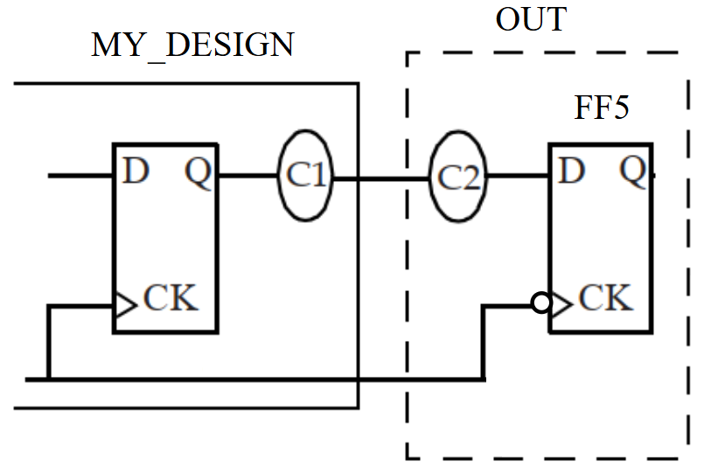  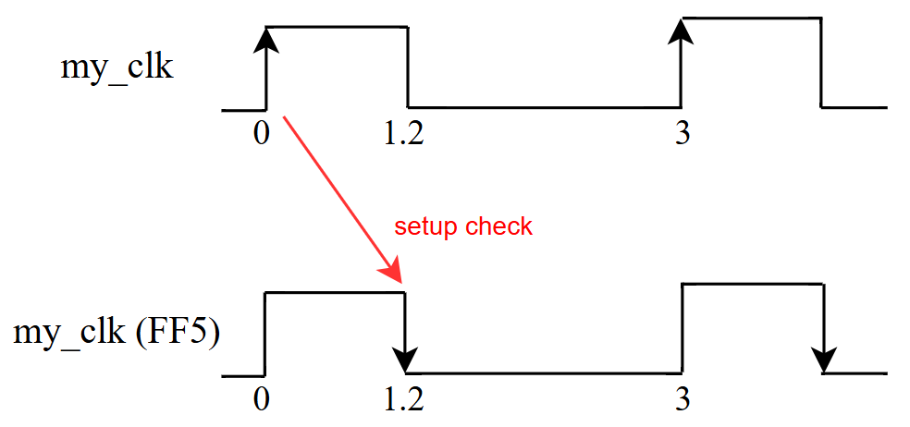  - Because of this is type half cycle path, so we will check setup slack at edge as above image.  - The -max -0.94 is calculated as follows:  Setup Slack = Trequire – Tarrival ≥ 0  = (T + t_{capture} – t_{setup} – t_{comb2}) – (t_{ck2q} + t_{comb1} + t_{launch}) ≥ 0  = (T + T_{out}) – (t_{ck2q} + t_{comb1} + t_{launch)} ≥ 0  = 1.2 + T_{out} – 0.26 ≥ 0  → T_{out} ≥ -0.94  + set_output_delay defines how long before the capture clock edge the output data must be valid for correct setup timing.  + -clock my_clk references the timing of the capturing clock (F5).  + -clock_fall specifies that data is captured at the falling edge of F5’s clock.  + -add_delay ensures compatibility if more output constraints are later applied.  + [get_ports out1] targets the exact output port.  + This command models the setup relationship between the last register inside MY_DESIGN and the external capturing register F5.  + It helps DC perform accurate setup slack analysis, considering both internal logic delay and external clock propagation.

IV. External Load, Inputs Ports
DESIGN SPECIFICATION | COMMAND AND  COMMAND EXPLANATION
1. Each input port (except clk) fans out to 2 other sub-blocks, which each drive the equivalent of 3 bufbd1 (input pin I) buffers internally.  Model this external capacitive loading on the inputs. | Command:  set_driving_cell -max -lib_cell bufbd1 [remove_from_collection [all_inputs] [get_ports clk]]  Explantion:  + The set_driving_cell command assigns a driving cell model for input ports.  + -lib_cell bufbd1 defines that each input port is driven by the standard-cell buffer bufbd1 from the library.  + -max specifies that this setting applies to the worst-case (maximum) timing condition.  + [remove_from_collection [all_inputs] [get_ports clk]] ensures that the clock input (clk) is excluded from this setting.  + This command helps DC model realistic input transition (slew) values based on the drive strength of the external buffer.

